Author: Chistopher T. Bahinting

Bahins Web and Software Solutions

Purpose:

The purpose of this website is to offer affordable and professional software and website development services to small businesses and service-based establishments. These include small stores, online shops, salons, massage spas, water refilling stations, and similar businesses. The site will showcase available services, pricing options, portfolio samples, and a contact form to help small business owners easily start their digital journey.

Goals:

* Attract and inform small business owners about our software and website development services.
* Generate leads through a contact form or quote request system.
* Showcase my portfolio and previous projects with client testimonials to build trust and credibility.

Target Audience:

* Small business owners
* Service-based entrepreneurs
* People with little to no tech knowledge who need a website or software system for their business

**Scenarios**  
The website should answer the following scenario questions:

* What types of software or websites do you build for small businesses?
* How much does it cost to get a website or software project done?
* How long does it usually take to complete a project?
* Do you offer support or updates after the project is finished?
* Can I see samples of your previous work or client testimonials?

**Site Map:**

Home

Services

Portfolio

About us

Contact us

**Branding Logo:**



Style Guide:

**Color Schema**

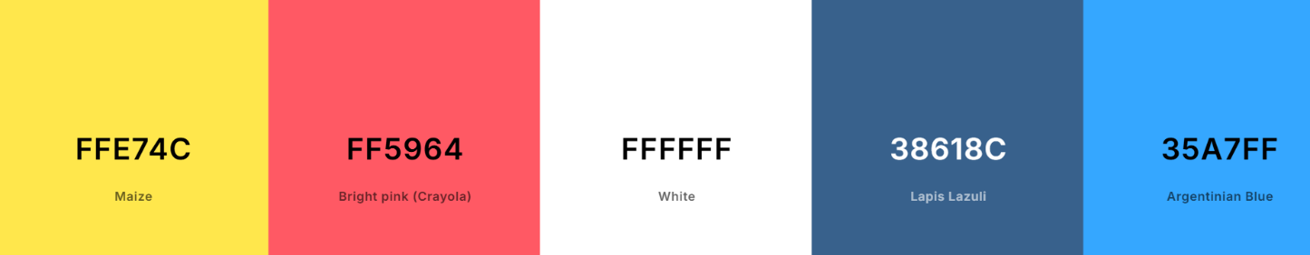Color Palette URL: https://coolors.co/ffe74c-ff5964-ffffff-38618c-35a7ff

**main background and text for colored background**

**highlights, badges, warnings**

**hover states, or urgent calls to action**

**links, icons, call-to-actions**

**headers, main buttons, or nav bar**

**Secondary Highlight Background Primary Accent**

|  |  |  |
| --- | --- | --- |
|  |  |  |
|  |  |  |
|  |  |  |
|  |  |  |
|  |  |  |

**#333333 – dark gray for body text**

**Typography**

<link rel="preconnect" href="https://fonts.googleapis.com">

<link rel="preconnect" href="https://fonts.gstatic.com" crossorigin>

<link href="https://fonts.googleapis.com/css2?family=Roboto:ital,wdth,wght@0,75..100,700;1,75..100,700&display=swap" rel="stylesheet">

Heading: **Roboto, Bold 700**

.roboto-<uniquifier> {

font-family: "Roboto", sans-serif;

font-optical-sizing: auto;

font-weight: 700;

font-style: normal;

font-variation-settings:

"wdth" <width>;

body: **Lato Regular – 400**

**<link rel="preconnect" href="https://fonts.googleapis.com">**

**<link rel="preconnect" href="https://fonts.gstatic.com" crossorigin>**

**<link href="https://fonts.googleapis.com/css2?family=Lato&family=Roboto:ital,wdth,wght@0,75..100,700;1,75..100,700&display=swap" rel="stylesheet">**

.lato-regular {

font-family: "Lato", sans-serif;

font-weight: 400;

font-style: normal;

007D